# PRACTICAL 8

## AIM: Prepare design document for your project (MS Visio (Desktop Tool) or Draw io (Web Tool)).

**Software Required: Smart Draw, MS Visio, Draw io (any) Knowledge Required: Basics of Software Engineering**

**Use case diagram:**

**Actors:** Primary Actors are actor(s) using the system to achieve a goal. Secondary Actors are actors that manage the system and help in achieve the primary actor's goal.

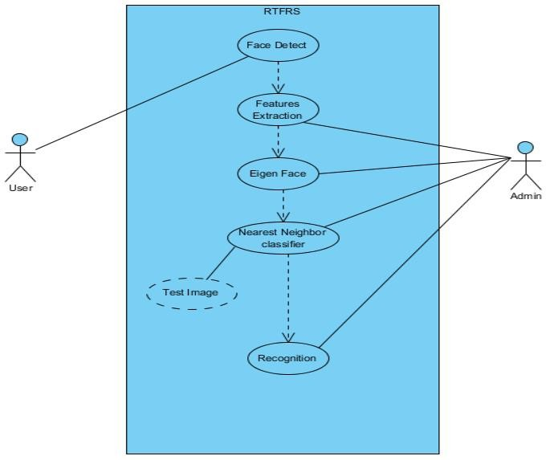

Use case

## DFD (Level 1 & 2):

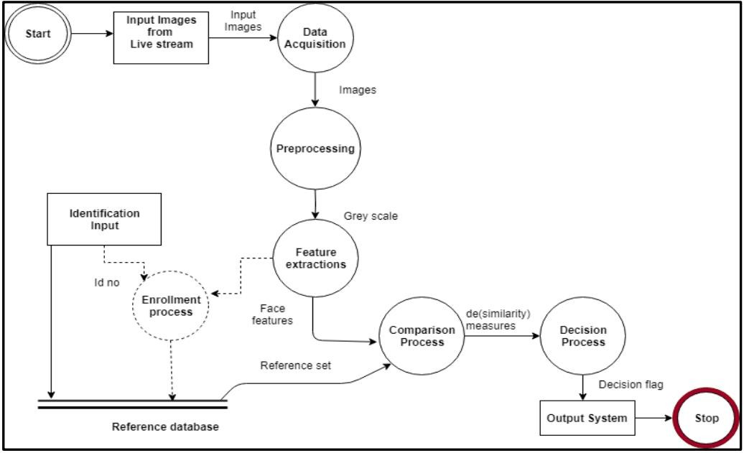

**Activity Diagram:**

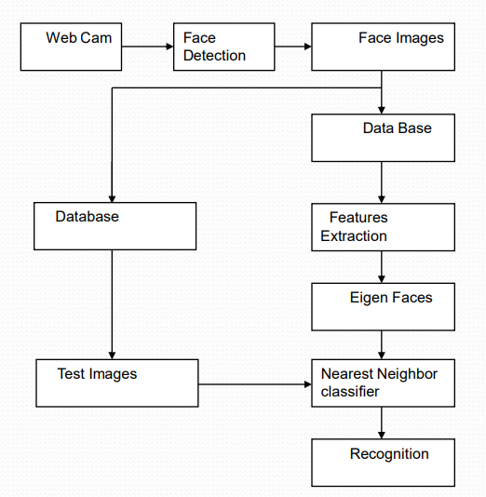

**Class Diagram:**

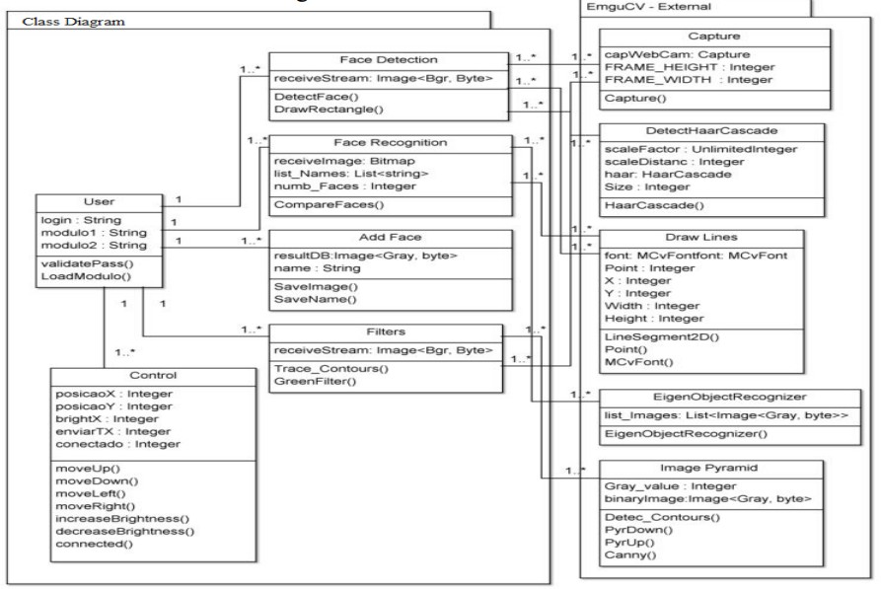

**CONCLUSION**:

In this practical we learnt about the various diagrams of Software Engineering.